
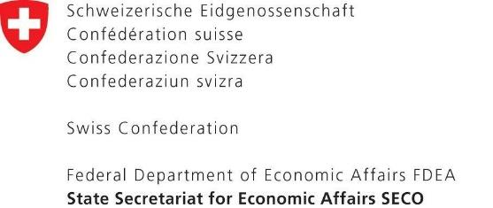


- Les entreprises à consulter
 | Nom du bureau | Nom de l’expert | Email
1 | ENER | SOUAYED Monji | m.souayed@ener.com.tn
2 | CAMI ENGINEERING | KHEMIRI ADBELHAK | cami@gnet.tn
3 | ASSELEC |  | asse1008@gmail.com
4 | Ingénieur conseil : DOUZI ABDELHAMID | DOUZI ABDELHAMID | douzi_abdehamid@yahoo.fr
5 | BERI | TURKI MOUNIR | beri.sfax@tunet.tn
6 | ELITE ENGINEERING COMPANY ( CETBI) | CHERIF HASSAN | cetbi@gnet.tn
7 | RAYAL ELECTRIQUE | SAHNOUN LILIA | liliasahnoun3939@gmail.com
8 | FLUENCO | ABDELHEDI OMAR | omar.abdelhedi@gmail.com
9 | KESSENTINI MOHAMED | KESSENTINI MOHAMED | kessentini.mohamed@yahoo.fr
10 | MORJENE SANA | MORJENE SANA | morgenesana@gmail.com
11 | CRA2E | CHAMMEM MAROUEN | cra2e@yahoo.fr
12 | HMIDETTE ZAHRA | HMIDETTE ZAHRA | zahrahmidette@gmail.com
13 | BEN MEFTEH BADREDDINE | BEN MEFTEH BADREDDINE | badreddine.benmefteh@yahoo.fr
14 | BEA INGENIERIE | JEMLI KHALED | beaingenierie@gmail.com
15 | AT & C | AMEIMEA NEJI | kais.boudaya@action.com.tn
16 | STE BATIMENT A BASSE CONSOMMATION (B.B.C) | MARRAKCHI AMAL | bbcetude2016@gmail.com
17 | BOUKCHINA SEMI | BOUKCHINA SEMI | cfcsami@yahoo.fr
18 | INFINITE ENERGY INTERNATIONAL | CHHOUD MOHAMED | contact@inf-energy.com
19 | STEG ENERGIES RENOUVELABLES | HAMROUNI MONTASSAR BELLAH | steger@steg-er.com.tn
20 | BEN MOHAMED LASSAD | BEN MOHAMED LASSAD | lassaadmed12@gmail.com
21 | SCET-TUNISI | BEN ABDALLAH WALID | direction@scet-tunisie.com.tn
22 | INNOV ENGINEERING | BEN JEMAA NIZAR | nizar@innov-engineering.com
23 | AOUN ANIS | AOUN ANIS | aoun_anis@yahoo.fr
24 | ALI IMED | ALI IMED | b2e.ing.imedali@gmail.com
25 | BEN HMED ABIR | BEN HMED ABIR | benahmedabir@hotmail.fr

